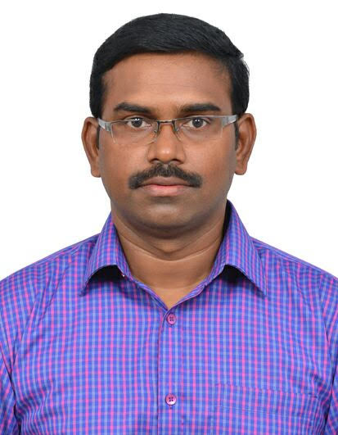 |  | 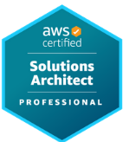 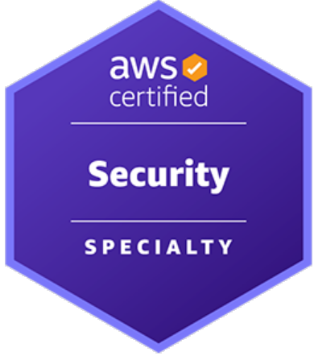 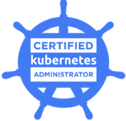 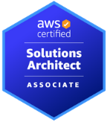 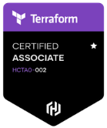  Kombaraj Arumugam  S o l u t i o n s A r c h i t e c t
Profile  Accomplished Solution Architect contributing 20 years of experience in Infrastructure, Application, Security, DevOps, IT service management and Support disciplines.  Possess valuable insight to deliver complex solutions for Business Opportunities with expertise in planning on Technical benefits Vs solutions costing to enable business drive maximum potential and optimum Business Risk Appetite.  Possess Industry recognized certifications in Architecture, Cloud and Infrastructure.  Contact  PHONE:  +91 8903692598  EMAIL:  kombaraj@gmail.com  LinkedIn:  https://www.linkedin.com/in/sathish2304/ |  | Objective  To Become a Visionary leader and a Solution Architect who deals with Technology disruptions and supports enterprises in their digital transformation journey.  Experience Summary  Wipro Technologies [Senior Architect] - Oct 2006–Till Date  IBM Global Services [System Operations Senior Specialist] - Sep 2005–Oct 2006  SRAS Global e-Services [System Administrator] - Oct 2003–Sep 2005  Hi-tech System Installation [Service Co-Ordinator] - Oct 2003–Sep 2005

Certifications  AWS Certified Solution Architect Professional  AWS Certified Security Speciality  Certified Kubernetes Administrator  AWS Certified Solution Architect Associate  Certified Terraform Associate  Acclaim Profile  https://www.credly.com/users/kombaraj-arumugam |  | Wipro Technologies  Wipro Digital – Cloud Practice – Aug 2017 to till date:  As a Senior Cloud Solution Architect responsible for:  - Designing Solutions for Wipro’s Cloud Studio platform  - Designing cloud migration solutions for several global customers as part of RFP and RFI.  - Designing Cloud native solutions for Greenfield App development and Re-architecting existing applications.  - As an AWS Well Architected Ambassador conducted Well architected reviews for several customers.  - Performing Proof of Concepts for new services  - Delivering Large scale cloud migrations  Key Projects Delivered  A Leading Insurance Service Provider Based at US  - Performed Cloud Amenability Assessment, R-Lane Assessment for the Applications and created a Migration Plan.  - Designed Landing Zone Architecture and Application Deployment Architecture.  - Migrated their Digital Marketing applications from On-premises to Cloud  - Solution Highlights:  - Implemented a Multi account landing zone architecture with Shared Service Account, Security Account and Log Archival Account and custom accounts for various business units.  - Implemented Palo Alto firewalls for perimeter security, Trend Micro for Endpoint Security and Qualys for Vulnerability Assessment.  - A Website Backup Solution to store backup files in a Glacier Vault with Vault Lock to meet sec rule 17a-4f issued by U.S. Securities and Exchange Commission.  - Log Aggregation using AWS Elasticsearch, Kinesis and Kibana (EKK) Services.  - IPSEC Tunnels between AWS Environment and Corporate network using Palo Alto Firewall.  - Network Load Balancer for Load Balancing.  - Path Based Routing using HAProxy on the Webserver to support B2B Integration.  - Lambda Functions for Starting/Stopping instances and Snapshot Backups.

CLoud Solutions Developed  - Developed terraform templates for provisioning Infrastructure for SAP on AWS and GCP.  - Designed and implemented a Serverless solution for Audio file transcription using AWS Transcribe.  - Designed and Implemented a Chatbot for Environment management using AWS Lex service.  - Developed a Food Diary Application using AWS Honeycode  - Developed an Alexa skill to query Elasticsearch  POC/POV Developed  - Cloud Endure POC for Re-Host Migration and Integration with Cloud Studio Platform  - Unbreakable DevOps pipeline leveraging Dynatrace  - Unbreakable DevOps pipeline using AWS native DevOps tools  - Serverless Point of View.  Competencies  - Cloud Technologies: AWS & Azure  - Unix: Linux, RHEL, SUSE Linux  - Automation: Shell Scripting, Python Scripting  - Virtualisation: IBM Power Virtualisation, Red hat Enterprise Virtualisation, VMware  - Containerization: Docker, Kubernetes  - Configuration Management: Ansible  - Continuous Integration: Jenkins, AWS Code-Pipeline. GoCD  - Infrastructure as a Code: Terraform  - Application Packaging: Maven, Build Packaging using HPSA, CSA and HPOO, AWS Codebuild  - Programming Language: Python  - Reverse Proxies: HAProxy, Apache  - Source Code Repositories: Git, AWS CodeCommit  - Deployment Tools: AWS CodeDeploy, Terraform  - Databases: MySQL  Key Strengths  - Ability to lead engagements and manage stakeholders  - Adept at working in high pressure environments with strict deadlines and multiple deliverables.  - Keen understanding in identifying areas for improvement and re-aligning strategies & operations to optimize operational cost and performance enhancement  - Self-motivated Team Leader having ability to lead cross-functional teams in multi-vendor environment and to integrate their efforts to maximize operational efficiency.  - Ability to unlearn and learn quickly  - Hands-on Architect  - Excellent track record of handling complex projects  - Good Troubleshooting skills  - Strong knowledge on Infrastructure, Application and Security domains.  - Positive attitude towards challenges  Education  Birla Institute of Technology & Science (BITS), Pilani - India  Bachelor of Science – Information Systems  Diploma from State Board of Technical Education Chennai  Computer Technology  Sankar Polytechnic College  PERSONAL DOSSIER  Passport Number:  Nationality: Indian  Address: |  | A Leading Telcom Service Provider Based at Germany  - Performed Cloud Discovery, R-Lane Assessment for the Applications and created a Migration Plan.  - Participated in Design discussions with AWS professional services for AWS Landing zone setup.  - Designed a solution for DNS using Route53 resolvers  - Participated in Network planning discussions with customer’s network teams.  - Designed Target Application architecture for 40 Applications  - Solution Highlights  - Terraform and Ansible for Infrastructure as a code and Configuration Management.  - Autoscaling groups for High-availability  - AWS Kubernetes Fargate Clusters for hosting containers  - Re-platforming applications hosted on Solaris to Red Hat Linux  - Upgrading Java, Tomcat applications to support Cloud hosting.  - AWS Transit Gateway with Direct Connect Gateways for On-premises connectivity  - AWS Route53 resolvers for DNS resolutions between On-premises and AWS.  A Leading Telcom Service Provider Based at Bangladesh  - Designed Landing Zone Architecture and Application Deployment Architecture.  - Landing Zone Setup  - Network Planning  - AWS Transit Gateway with VPN Gateways for On-premises connectivity  - Centralized logging solution  - Archival Storage Migration using AWS Snowball  A Leading Health Care Service provider in US- Solution Architect- Migrating WebSphere applications to Google Cloud  - Designed a solution to migrate customer’s WebSphere landscape to Kubernetes clusters hosted in Google Cloud Platform.  - Solution Highlights:  - Migrating applications hosted on WAS 6 and WAS 7 with ND to WAS Base 8  - Containerization of the application using Wipro’s Containerization accelerator  - ISTIO Service Mesh for Managing Service to Service communication and Security  - Stackdriver monitoring  - CI/CD pipelines using Git, Jenkins and Spinnaker.  - Container Vulnerability scanning using Clair  Leading Retail and Commercial Bank based at UK –Feb’2010 to Aug’ 2017:  - Technical Architect – Infrastructure Project Design  - Developed TOGAF based architecture solutions and artefacts fulfilling Non-Functional Requirements (NFR’s) for various business CIO’s.  - Worked extensively in Design Artefacts and Technology Patterns for Cloud, Digital, and Cyber Reference Architecture  - Cloud Consulting for Cloud service models like IaaS, PaaS and SaaS  - Designed Single Sign on solutions using Active Directory Federation servers and SAML Tokens.  - Designed Cryptographic key management solution using CloudHSM.  - Designed Multi Availability Zone/Multi Region solutions in AWS Cloud that meet RTO and RPO requirements.  - Enterprise and strategic level designs, solution road maps, Effort Estimation, Cost Estimation.  - Designing data retention, backup, and recovery methods and plans based on Business RTO/RPO specifications  - Diligently outlining Methods and Technique towards POC/POV projects in collaboration with product owners and other stakeholders in the project  - Design Assessment & Gap Analysis for enabling new features/functions in existing environments  - Security triage and design reviews  - Architecture consulting to support Change Requests / minor design modifications in existing solutions.  - UNIX Engineering Consultant – UNIX Exploitation & Governance Team  - Creating Low Level Designs from Architecture Artefacts and Organization Technical standards.  - Securing AWS Resources using Bucket Policies, User Policies, Security groups and NACL’s.  - Deploying resources using CloudFormation templates  - Deploying Docker containers using AWS ECS.  - Directing Project Teams in decision making on UNIX design solutions governance forums  - Drafting Proof of concept (POC) testing for all new technologies in the architecture artefacts.  - Scripting / creating workflows for Build Automation, Audit Policies, Software Policies and Application Packaging.  - Testing and Overseeing Patch Management, Hardware Patterns,  - Contributing in UNIX Technical Roadmap and strategy using knowledge base from Industry best practices, International Technical forums  Leading Energy and Utilities Customer based at Netherlands– Oct’2006 to Dec’2009:  Customer was running SAP Application on AIX OS. IBM HACMP was used for high availability and Power Virtualisation was used for Virtualisation. Played several roles for the customer as BAU Support, AIX SME and Technical Consultant in Unix Service Engineering team based at Netherlands.  My primary roles and responsibilities in this project are as follows:  - As an IMG Engineer, Handled L1 & L2 Infrastructure Incidents, Performed ESS to USP Migrations, TL Upgrades, Firmware Upgrades etc  - People Management - As a Shift Lead, handled and mentored 10 people team, assigned appropriate engineers to support escalation  - Served as single point of contact for all technical escalations in AIX support.  - As Unix Technical consultant in engineering team, contributed below roles / documentations  - Defining the Road map and Strategy for UNIX platform across Shell IT estate.  - Reviewing and defining rollout plans for relevant APAR’s after environment testing.  - Testing AIX Technology Levels, Updating Images on NIM Server, and Defining procedures for rollouts as per Shell’s Release Management schedule.  - Performing RCA’s for Major Incidents and recurring problems.  - Automating tasks using shell scripts to achieve reliability and accuracy  - Providing Hands and Eyes Datacentre Support for Major Changes  IBM global Services  Supported several Global clients like Pfizer, Boots, Heinz, etc. As a System Operations senior specialist was responsible for maintaining Linux servers, Patching, Job Scheduling and Backups.  SRAS GloBAL e-services  As a System administrator responsible for maintaining customer’s Linux servers, taking periodic backups of Databases, Patching Linux servers, Firmware upgrades on Hardware, troubleshooting batch jobs and Configuring NFS File shares.  Hi-tech System Installation  As a service coordinator responsible for handling Installation, Maintenance and service of Electronic data capture (EDC) terminals for processing credit card transactions. Also responsible for managing the SNC (Linux Server) which maintains the link from Merchant location to the central hub in Mumbai.

